Stat 91r

Schedule

Done so far

1. Scrape the NHL data in 2013-2014 and 2014-2015 season.

Divide all goals into three categories.

1st Assisted Goal, 2nd Assisted Goal and Non-assisted Goal.

Categorize the 1st assists into 2ndAssisted- 1st Assisted Goals.

Categorize players on the ice into three types (players on the ice when non-assisted goals are scored, 1st-assisted goals are scored, 2nd-assisted goals are scored)

2.

Based on the scraped data, predict goals while a player is on the ice in the following season by using his performance in the previous year.

Right now we only think about equal-handed situations.

3.

I decide to divide the datasets into the data of forwards and the data of defensive players.

Defenders

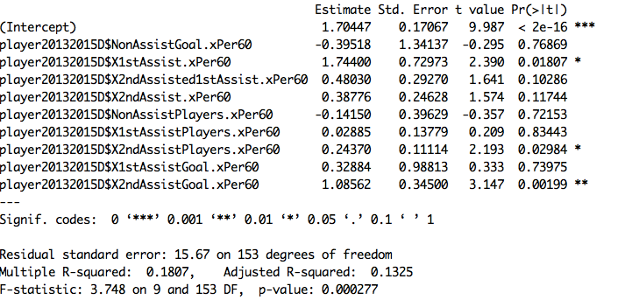

Forwards

All the players on the ice

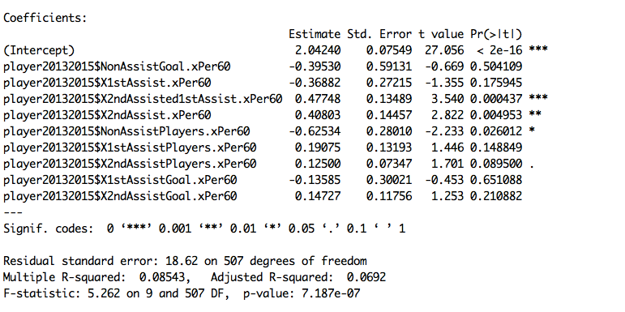

All the defenders on the ice in 2012-2014

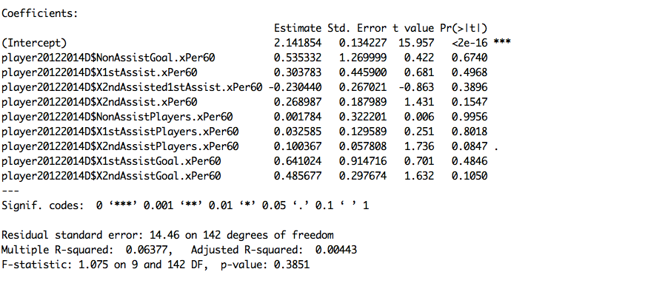

All the forwards

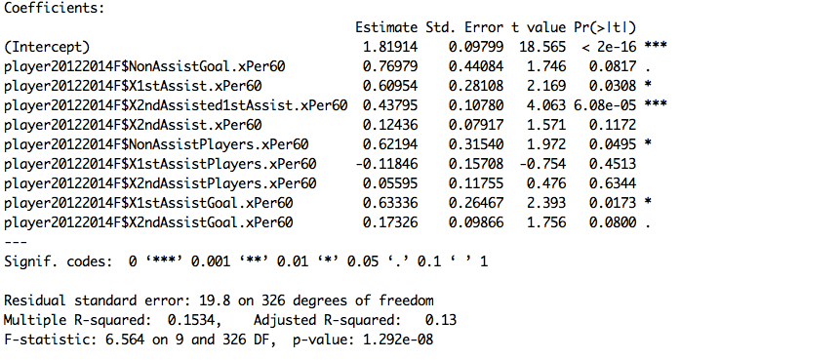

All the players

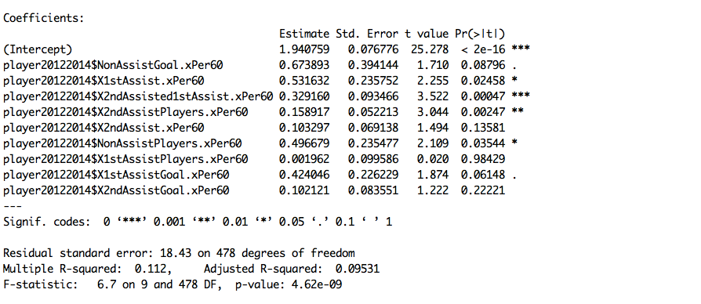

Strike season

Why only look at the forwards

Time on the ice (Why I chose 500 minutes)

Why did I transform the x variables

Graphical Justification

2011-2013

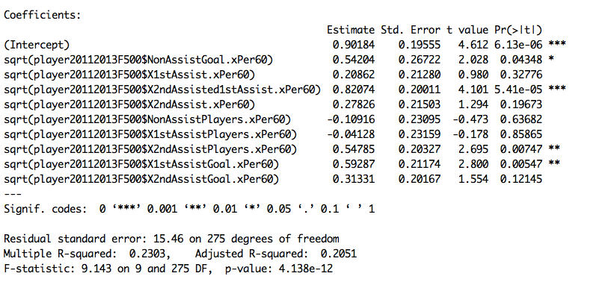

2012-2014

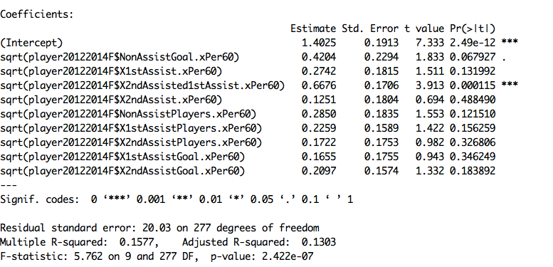

2013-2015

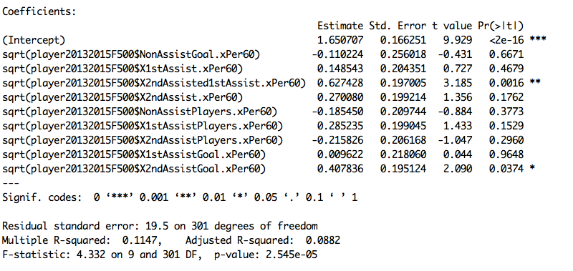

Try to come up with some pairs of data that illustrates the result

Two players very similar results for the predictions season

Two well-known players play the same amount of minutes

Very similar results except for the variable of interests

Take all the coefficience except the variable of interests

Predict everyone except the 2ndassisted1stassists

Rank 300 players based on prediction model ()

Write up Paper

Defense